DOCUMENTATION

* Star techies

**ABSTRACT :**

This report represents the mini-project assigned to third year students for the partial fulfillment of hackathon, Machine Learning, given by the department of computer science and engineering, KIET in collaboration with Ineuron.

Trading is an interesting and exciting endeavor, offering the best excuse to engage with the markets in a meaningful way. It is going to be a lot easier to trade effectively with new data analytics tools. However, while there are lots of reasons people decide to become traders, the most common incentive by far is money. There’s nothing wrong with trading to boost your income, but you’re sorely mistaken if you think it’s a way to get rich quick. Truly profitable traders know it doesn’t work like that at all. Thy have to take advantage of the latest big data technology to have a competitive edge in this convoluted market.

Overview of the project :

The object of the project is exploratory data analysis of stock marketing data i.e, the project analyses the data from the past and is analysed to run into machine level algorithms which predicts the rise and decrease of stocks.

**Objectives** :

The main objective of developing this project are:

1. To analyse data on stocks

2. To determine significant risk factors based on past data.

3. To analyze feature selection methods and understand their working principle.

**DATASETS :**

The dataset is publicly available on the Kaggle Website.It provides information of NIFTY-FIFTY (ADANI PORTS )past prices since 2000-2021

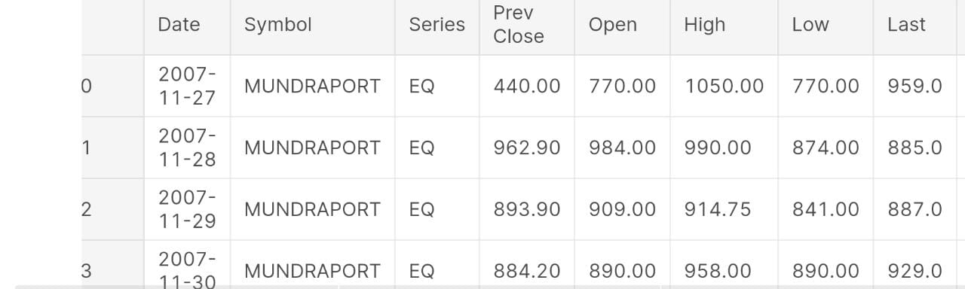

**Contents covered in the project :**

1.which is the most trading day?

2.which month we had seen trading all time high?

3.what is the trend of trading year over year?

4.what is the highest and lowest turnover?

5.highest and lowest volume days?

**COLUMNS FOR ANALYSIS :**

1. Volume
2. Trades
3. Turnover
4. Date for analysing over year analysis
5. High and Low

**Tools used :**

* pandas
* numpy
* scalers
* condaprompt
* jupyter notebook
* for visualization use matplotlib, seaborn is used
* log function

DEPLOYMENT PROCESS :

* Start -> load -> open jupyter notebook -> analyse the data -> desired output is ready to put into machine learning algorithms -> predict stock price

CODING PROCESS :

Start with reading data into dataframes

Search for the missing value and plot a barchart on the missing values

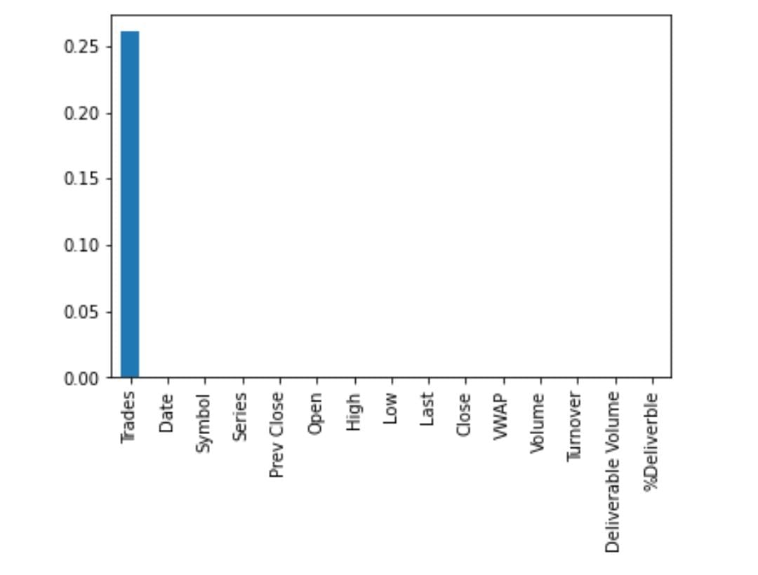

For better visualization of data import seaborn

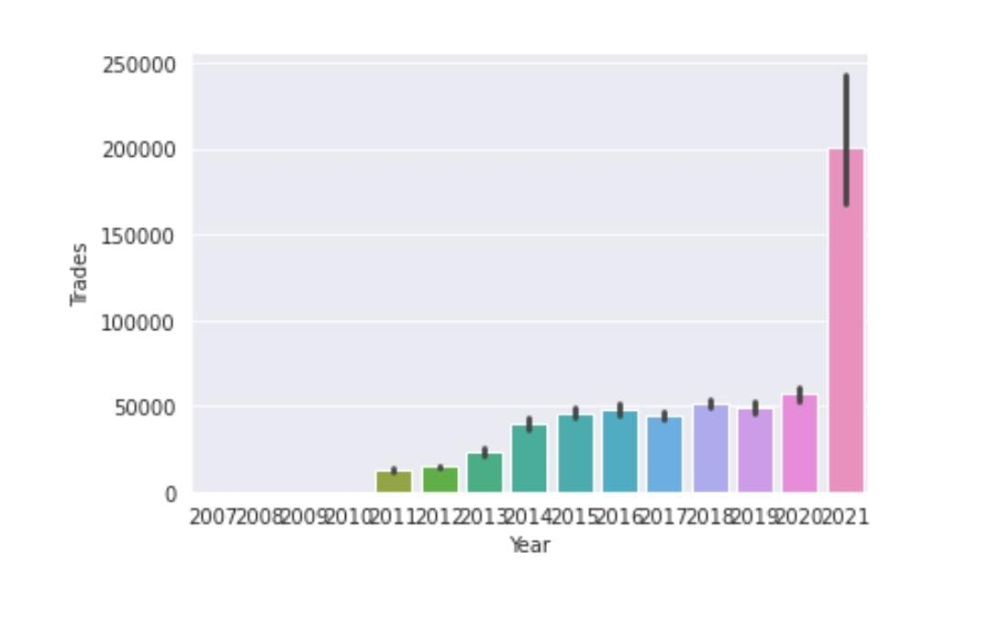

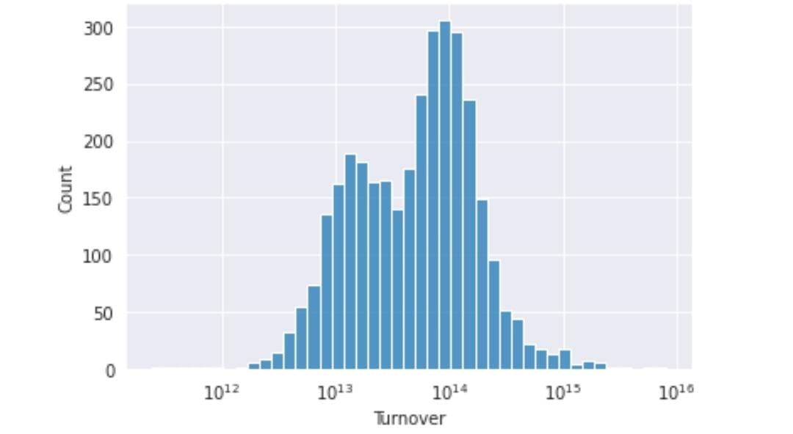

Plot histogram according to the volumes

Now analyse the data from above visualistions

ERROR HANDLING :

the main error “module not found” was resolved by installing tensorflow

CONCLUSION ANALYSIS :

* The days when volume was greater than 50,00,000 on basis of everdays volume is 14.39%.
* The days when volume was less than 5,00,000 on basis of everdays volume is 17.24%.
* The days when No. of trades was greater than 70,000 on basis of everdays is 13.57%.
* The days when No. of trades was less than 10,000 on basis of everdays is 7.44%.
* Usually after analysis we can say most trading days are from monday to friday. There is usually less or no to trading on saturdays and sundays.
* We have seen the most trading month after the analysis is month of APRIL.
* Talking about the trend of trading on basis of years, we can say that it has only increasd and for till now with analysis we can say that 2021 year is the most trading year.
* Highest turnover of the company = 1205984.0
* Lowest turnover of the company = 366.0
* Talking about volume, then in 2007 company have bigger volume and then it decreased and then it is started increasing from 2012 from then it has increased.
* April month is the most happening month for volumes of the company.